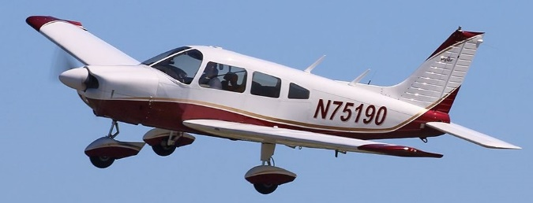

FAA FLYING CLUB (ACY)

Membership Application

Please complete this form and email to Dan.Dellmyer@FAA.GOV. Include a copy of your pilot and medical certificates (if you possess them). A $150 initiation fee will be included on your first bill.

Name:

Routing Symbol:

Company Name (if contractor):

Work Address

Home Address

Email:

Phone: Alternate Number:

Fill out the following if applicable:

Total Flight Time: Last 12 Months:

Aircraft Single Engine Land Flight Time: Last 12 Months: ______

Ratings: Date of last flight review:

Medical Date: Medical Certificate Type:

Brief statement of any accidents/suspensions and date(s):

Desired membership date:

This is a formal application to join the FAA Flying Club, Inc. I have read and will follow the Constitution, By-Laws, and operating rules of the Club.

Signature: Date:

